Printing Cube Test SOP

This process is to be initiated once per month to verify minimum dimensional quality of our product from the print room processes. Please check appropriate Trello boards for actual times or contact your team lead for more detailed information.

Step 1

Utilizing the nesting software for the printer to be tested, nest the test cube .stl file with any other models waiting to be printed. Resin type is not a concern of this test. The new cubes have axis available for proper placement. If you are unsure of anything, ask your team lead or other senior operator.

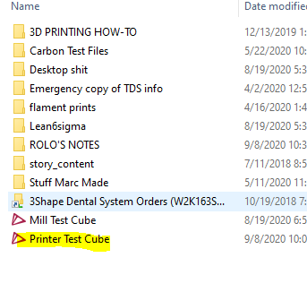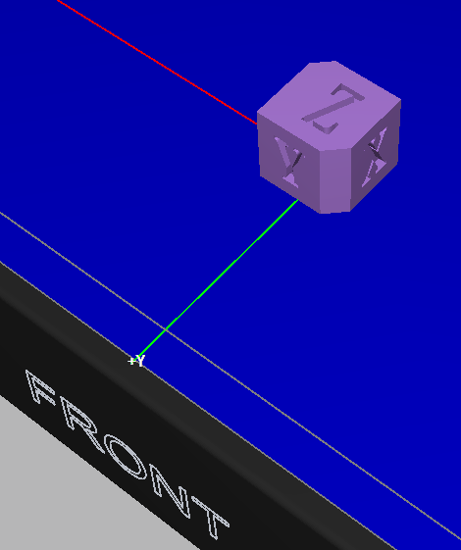

**Please be sure to place cubes in the center of the build plate and (optional) corners.**

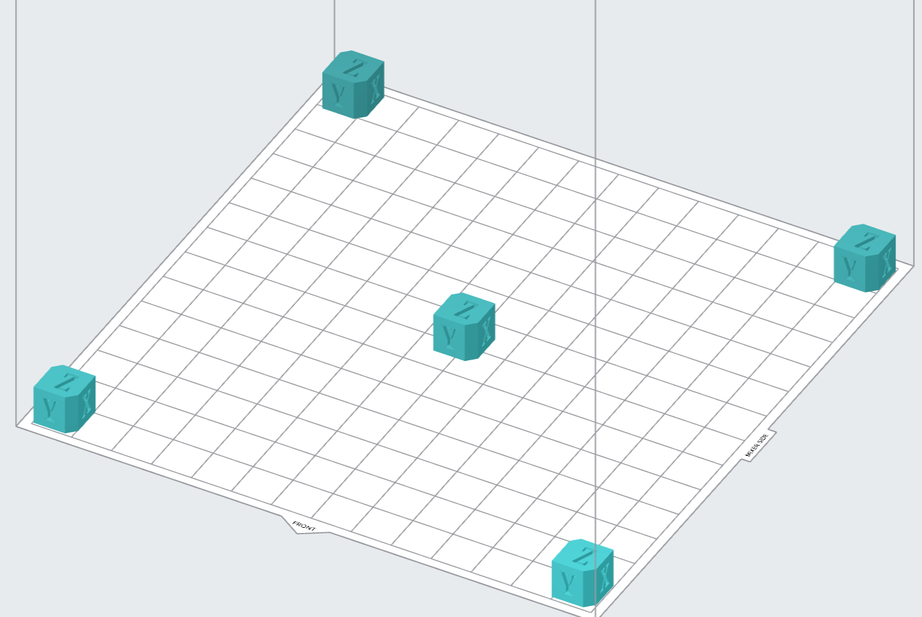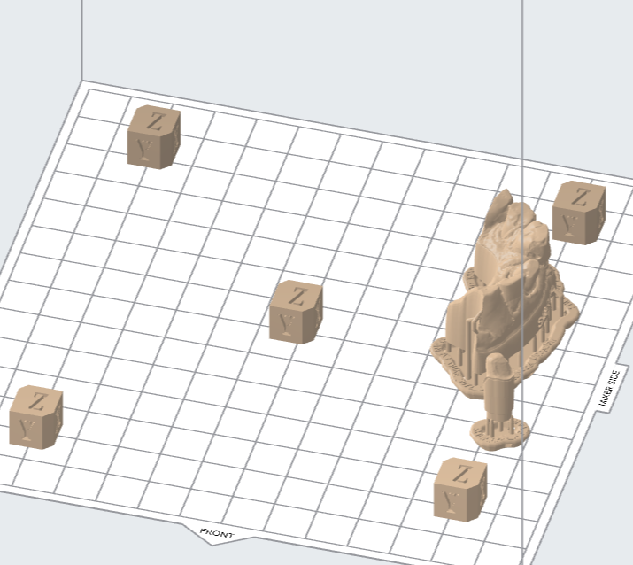

Step 2

Print the test cube and follow the rest of the printing process for models as usual. Take extreme care when removing the cubes from the build plate. **Take every precaution during processing of the cube to prevent dimensional changes** at the end of the line.

Step 3

Mark each cube with printer ID and carefully measure test cubes in X, Y, and Z axis.

Enter values into spreadsheet provided (print cube worksheet).

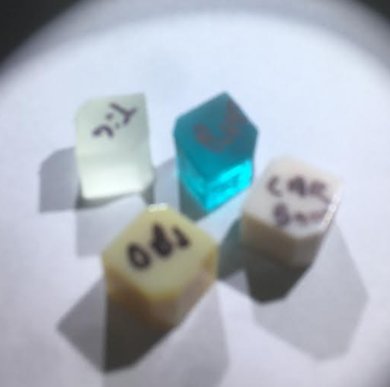

Please be aware that X and Y will change based on nesting. The exact position of these is not as important as the actual measurement. Only their dimensions will directly impact our product.

When documenting the caliper measurements, X and Y may be swapped with little affect. Z should always be Z on every cube measured. If you do not understand how to find an axis on the cube, stop and contact your team lead.

All axis measurements should be taken a minimum of five times. The mean of those five measurements should be entered as the “actual” axis measurement. If you do not understand how to find the mean of the caliper measurements on the cube, stop and contact your team lead.

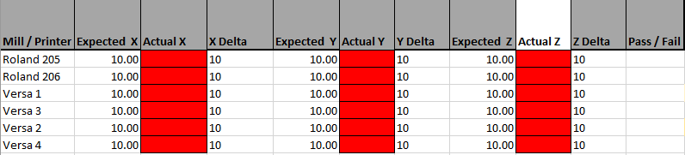

Step 4

**Anything above 10.2 mm or below 9.8 mm is failing and show by a red cell.**

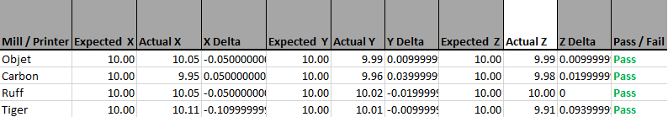

Passing values will show up white. If a printer has a failing value, remeasure the cube, recalculate the means, and re-enter the values in the spreadsheet. **If it is still failing, put the printer in question down** and contact your team lead**. No product may run on a machine that fails this test** unless otherwise directed by management.

Step 5

Finally, log info into Google form provided by Rolo in chrome bookmark.

